Reports
Produs IT enables you to create arbitrary reports. Some reports are already available and you can create new ones for your own needs.
Choose the Reports tab.
A list of folders with reports will open as shown on the picture below.
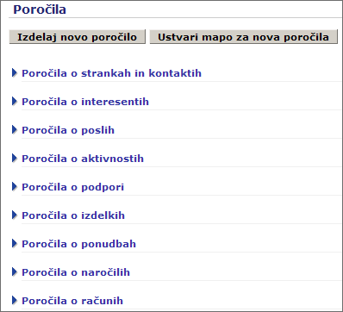

Using prepared reports
If you click on the name of the folder, a list of preset reports within this folder will open.
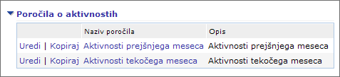
A click on the report's name opens it. There are some buttons above the listing that enable you to work with the preset report.
The preset report can be printed out in PDF format or exported into a MS Excel file.
The preset report can be altered and marked off if needed by using filters. It can be done with help of Filter Settings section, located at the top of the listing.
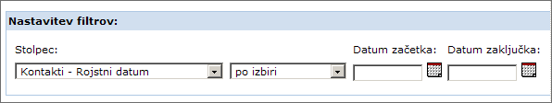
When the desired filters are set, click the Use Filter button.
If you wish to make changes to the preset report, click Settings.
=====Creating rep
ort

You can create an entirely new report or just remake the existing one by clicking Settings or Edit.
A new report can be created by clicking the Create a new report button, located at the Reports tab.
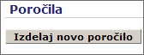
A new page will open, as shown on the image below.
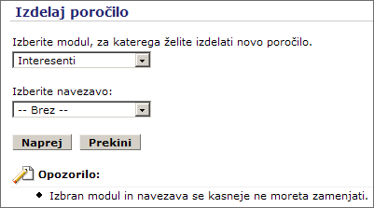
Choose a module you wish to create a new report for and choose which module it will be linked to. If we are interested in sales activities, we will choose the Opportunities module and link it to Tasks and events.
Click on Next confirms our choice of modules.
A new page for creating a report opens. 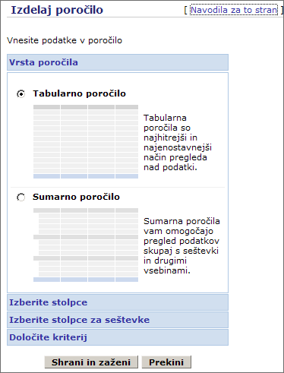
We can choose between a tabular or summary report. Tabular reports are the fastest and the easiest way of reviewing data. Summary reports enable reviewing data together with sums and other contents. Summary reports enable data grouping.
When you have chosen a type of report, you have to select columns to be included into the report.
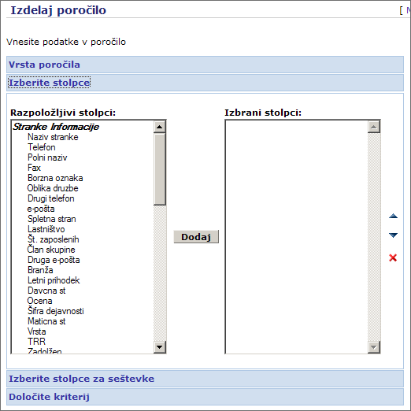
There are columns on the left, available to be included into the report. Select the field by clicking its name and then click Add. The field will appear in the right column.
When you have selected all fields, you can change the order of the shown columns.
If you wish to delete a field from the column list on the report, click the red „X“ below the sorting arrows.
If you have chosen a summary report, you can define data grouping in the next step.
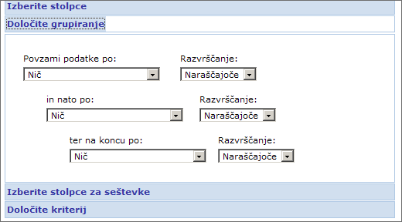
Clicking the toungelets chooses the way of grouping data in the report and if the listings should be arranged ascending or descending.
Finally we define the criteria for listings in the new report.
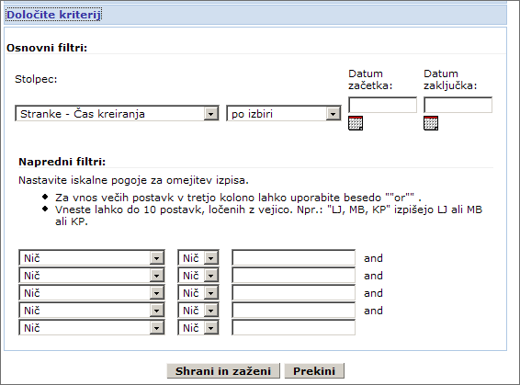
The criteria can be set with basic and advanced filters.
Finally click on the Save and run button.
A new window opens.
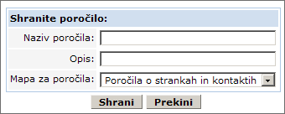
The name of the report should be entered into the Report name field. The Description field allows you to describe it in short. It is important to save the report into the right folder. You choose it by clicking the tonguelet.
Finish creating the report with clicking Save.

