HelpDesk
Produs IT enables central and common management, solving and managing tickets and remarks or wishes of buyers. Tickets are usually entered by users that are in Contact with an Account or work in a call center. Tickets are arranged later and their solutions are supervised.
Produs IT helps you choose demands, questions, annotations and problems, connected with particular products, sold to your customers. It is very applicable for maintenance and very easily examined by a sales team, which can quickly determine the condition with an individual customer or product you wish to sell.

Ticket
Tickets by definition are reclamations, remarks and wishes of Accounts and also what we have noted ourselves. It is important to save them into the system. Let us take a look at how to note a new ticket.
Click New Ticket on entry section to create a new Ticket. A new page opens (see picture below).
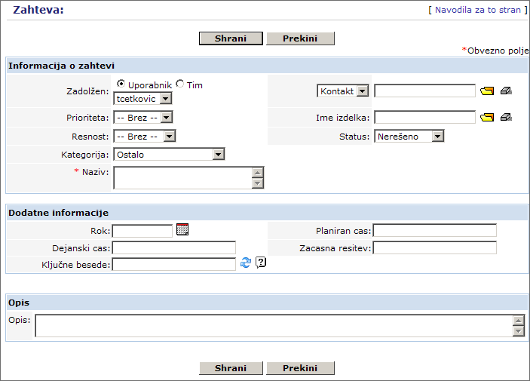
Enter the Ticket data. If there are more users entering the data, our advice is to agree and define entry standards. In this way all the entered data is unified. Redundant fields should be left empty or just give us a call and we will remove them.
Enter as much data as you can. Use all options for Ticket description: define Priority, Severity and Category in order to sort the Ticket in solutions and to make it easy to find later on.
Most fields do not need detailed axplanation, but let us mention few of them:
- Appointed
One user or a group of users can be appointed to solving Tickets. This person or group will be appointed to solving ticket or answering a given question.
- Priority, Severity and Category
This fields can help you define the importance of solving a specific Ticket so that persons appointed can plan their activities while salesmen and customers are informed of it.
- Subject
Every ticket should have a title.
- Contacts and accounts
The subject can be linked to the Contact person or an Account the person has given or the one that wishes to get an answer to a question. In practice we connect Tickets to Accounts, we name the subject and enter the name of the person who passed the Ticket.
- The Name of the product
Subject can also be linked to a specific product or service your company offers.
- Status
Set the actual status of the Ticket.
- Description
It is good to describe the Ticket beside just naming it, so its solving will be more effective.
You can fill in additional information.
- Appointed time
You can enter a date untill the Account wishes to receive a solution to the Ticket.
- Planned time, actual time
Fields serve for observing the planned and the actual time of resolving Tickets. Observing these two fields proves to be useful in further planning and arranging Ticket solving.
- Temporary solution
You can enter a temporary solution or the so-called „workaround“, offered to the Account untill the real solution is prepared.
- Key-words
Key-words help us see related Tickets that have already been planned for solving or have even been resolved.
On the picture below you can see a field for entering key-words with two icons beside it.
Clicking the folder icon will show a list of key-words, entered by the system administrator.
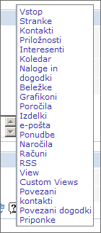
Clicking the other icon (circular arrows) will show list of Tickets with the same key-word in its title, description, solution, etc.
Tickets with at least one same key-word will be coloured green.
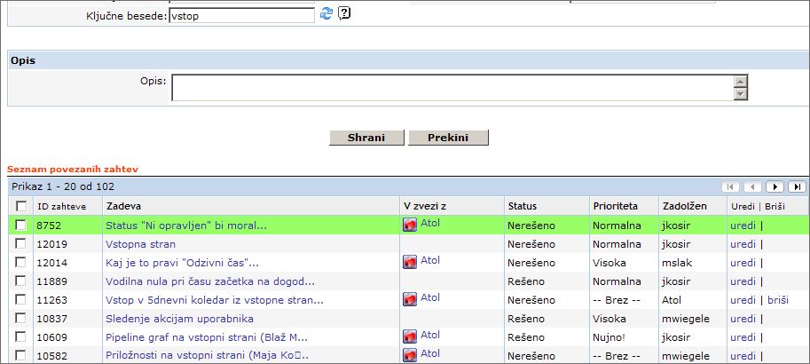

Working with Tickets
Clicking the Support tab will open a list of Tickets. Clicking the Ticket's title will open its detailed overview. A new page will open, as shown on the image below.
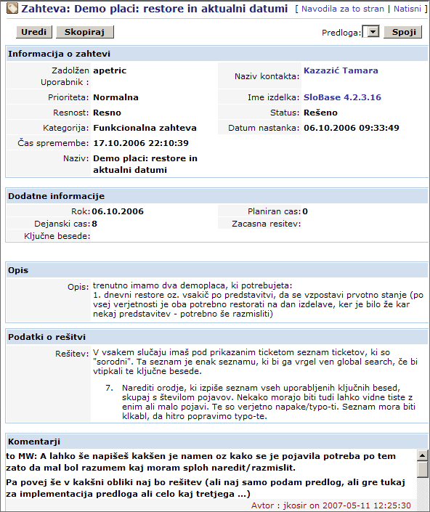
The Ticket can be edited by clicking the Edit button. You and your co-workers can supplement the Ticket's description untill it is resolved, enter comments and its solution. You can also attach documents and plan events and tasks related to the subject.
History of changes
Every change can go through different phases untill it is resolved. With managing changes it is possible to see the course of its resolution.

FAQ
Frequently Asked Questions can be used as a knowledge database for your Accounts and the employees of the company. You can enter frequently asked questions and answers to them, originating from the resolved Tickets. It is a way for your company to lower the number of asked questions about different products and easen the work of the helpdesk with standard procedures and already prepared answers to frequently asked questions.
The new FAQ can be entered by clicking the New FAQ at the field of entry.
A new page will open, as seen on the picture below.
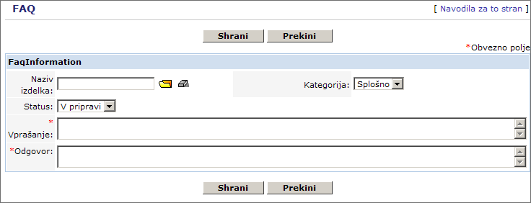
The new FAQ form enables you to enter the question and the answer. You can also make a link to the product or service and set the appropriate category.

