Products

About Products
In Produs IT Products are defined as real products and services offered by companies. Produs IT makes it practicable to classify Products by prices and suppliers, similar to a catalog.

New Product
Click New Product on entry section to enter a new Product. A new page opens (see picture below).
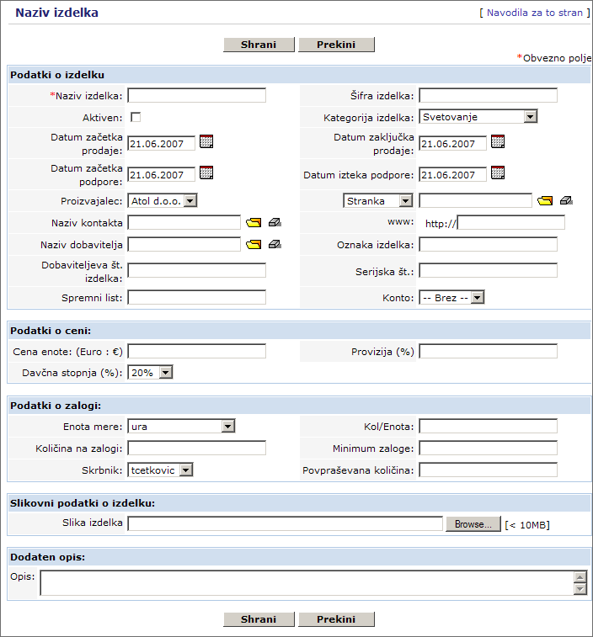
Enter the Product data. If there are more users entering the data, our advice is to agree and define equal entry standards. In this way all the entered data is unified. Redundant fields should be left empty or just give us a call and we will remove them.
Descriptions of particular field are as follows:
Product data
- Product Name:
Every Product or service has to have a unique name assigned.
- Product Code:
Every product should have its own code. It can be a combination of numbers and letters. This number can be also used when ordering.
- Product Active:
Product is active and for sell when this field is ticked off.
- Manufacturer:
Manufacturer is selected from a list. Produs IT administrator manages a list.
- Product Category:
Product Category is selected from a list. Produs IT administrator manages a list.
- Sales Start Date/Sales End Date:
Sales Start and End Date of Product can be determined.
- Support Start Date/Support Expiry date:
Support Start and Expiry Date for Product can be determined.
- Related To:
Product can be attached to a certain Lead, Account and Potential. Direct entries are not possible and have to be selected from a list of Produs IT.
- Contact Name:
Select Contact Name. Contact Name is a person that is contacted for more information about the Product.
- www:
Enter web page's additional data about Product.
- Vendor's Name:
Enter the Vendor's Name.
- Product Code:
Enter a Product Code, if Product has its own Code.
- Dobaviteljeva št. izdelka:
If the supplier sporočil št. izdelka za naročilo, you can enter it here.
- Serial No.:
Enter the Serial No. of the Product.
- Spremni list:
Here you can enter the oznako of spremnega lista.
- Account:
Enter account No. This field is very useful if Products are imported and exported into or from user's accounting programme.
Pricing Information
- Unit Price:
Enter Unit Price. Unit Price is also the purchase price, if Product is purchased from vendor. Your selling price can be different and is determined in your price list.
- Commision Rate:
Enter Commision Rate in percentage (%). Enter the prodajno provizijo.
- Tax Class:
Enter Tax Class of a Product. A list of Tax Class is edited by the administrator of Produs IT.
Stock Information
Produs IT also supports Stock management. Enter Stock data and define the person who is assigned to maintain the stock.
- Usage Unit:
Select Usage Unit of a Product that is in stock. A list of Units is edited by administrator of Produs IT.
- Qty./Unit:
Enter No. of Product/Unit (e.g. 15 pcs in one parcel).
- Qty. in Stock:
Enter Quantity in Stock of Product. This information uses Produs IT when offer, order or account are prepared. At every completed offer the Quantity in Stock is shown. It is automatically reduced when a Product is sold.
- Handler:
Select the assigned person. This user is automatically informed about Product sale through email, sent by Produs IT.
- Reorder level:
Enter minimum of Product Quantity that should be in stock all the time. When the stock is coming near minimum of Product Quantity, the Handler is informed through email, sent by Produs IT.
- Qty. in Demand:
Enter Product Quantity, the quantity that is purchased.
Product Image Information
- Product Image:
Image of a Product can be also attached. Image should be in .jpg, .gif or .png format. Do not use capital letters for formats (JPG, GIF, PNG). Size of image should be small for the page to open faster.
Description Information
- Description:
Enter additional data of Product, if any.
By clicking Save the entry is saved into Produs IT.

Import and export Products
A list of Product can be imported and exported into and from user's computer at any time. Please see the Importing and Exporting Data chapter for more detailed instructions on importing and exporting products.

Vendors
Unlimited number of vendors can be entered into Produs IT. Vendors are saved on another list and are not a part of Accounts or Contacts.
Click New|vendor on entry section to enter a new vendor. A new page opens (see picture below).
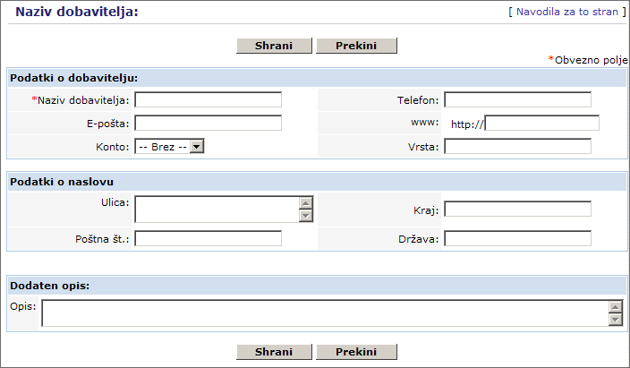
Enter the data of Vendor. If there are more users entering the data, our advice is to agree on equal entry standards. In this way all the entered data are unified. Redundant fields can be left empty or just give us a call and we will remove them.
By clicking Save the data is saved into Produs IT. Click the A list of Vendors tab. When on the Product tab, you can select the Vendors tab to see a list of vendors.

Price Books
Produs IT makes it feasible to work with unlimited number of price lists. That can be very useful if your company has different interest groups, demanding different prices. You can use cenike za maloprodajo, nadaljnjo prodajo, ali prodajo končnim uporabnikom price lists.
Click New Price on entry section. A new page opens and new Price Book can be created. See picture below.
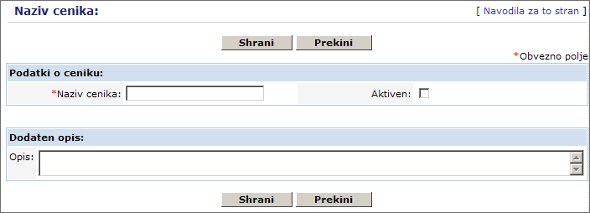
Enter the data of Price Book. If there are more users entering the data, our advice is to agree on equal entry standards. This way all the entered data are unified. Redundant fields can be left empty or just give us a call and we will remove them.
By clicking Save the Price Book is saved into Produs IT.

Editing Price Books
On the Product tab select Price Books. A list of Price Books opens. Click on a Price Book name to open the details.
Select optional Product or service from a list of Product and to this Price Book.??? Click Select Product in order to select product or service from a list of Product.
A new window opens. Select Product from a list of Products that is saved in your Produs IT.
Tick off Products that should be included into your Price Book. Product ??? price can also be included, if it differs from Product purchase price. You can also enter the price of the product for the namenski price list, if it differs from the purchase price of the product.
Entered price is valid only for this Price Book. Click Add to price list. Save the selection into price list.

