Contacts
All about Contacts can be read in the Contacts Management chapter. The instruction on how to use Contacts can be found below.
If Contacts and Accounts are entered manually, our advice is first to enter Accounts and then Contacts. In this way a new Contact is linked up with Account easily. Please see the Accounts chapter to read about how to enter Accounts manually.
For importing Contacts users do not need to enter Accounts previously.

New Contact
Click New Contact on entry section to enter a new Contact. A new page opens (see page below).
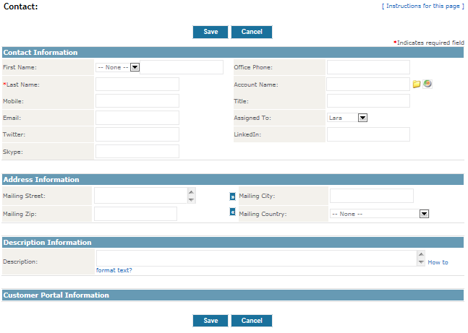
Enter the data of Contact. If there are more users entering the data, our advice is to agree and define entry standards. In this way all the entered data are unified. Redundant fields can be left empty or just give us a call and we will remove them.
Most of the fields are simple and do not need to be explained in details, for example:
- Surname
Surname is obligatory datum. This field has to be filled in in orded to save the entry.
- Name of Account:
Select an Account from a list according to Contact. Click on yellow folder by the field to open an Account list. A new window with existant and saved data in Produs IT opens. Window closes automatically after selection is done.
- Assigned To:
User should be selected from a list in order to be assigned for a Contact. User who enters the record is automatically selected by the system.
- Refused e-mail:
Contacts, marked with Refused e-mail, will not receive e-mails sent from Produs IT.
- Superior:
Superior is selected from a Contact list. Click on yellow folder by the field to open a Contact list. A new window with existing and saved data in Produs IT opens. A window is automatically closed after the selection is done.
- Assistant:
Assistant should be entered irrespective of being entered previously.
Click Save to save a record.

Import and export Contacts
A list of Contacts can be imported and exported from user's computer at any time. Please see the Importing and Exporting Data chapter of User's manual for more information and detailed instructions on importing and exporting Contacts.

