Accounts
All the information about the concept of Accounts can be found in Contacts Management chapter. In this section the instructions on how to use the Accounts module can be found.

New Account
Click New Account on entry section to create a new Account. A new window opens (see picture below).
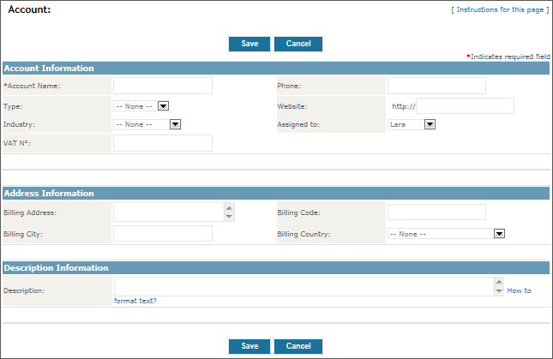
Enter the account information. Only information, relevant to you or your business, should be entered. Irrelevant fields can be left empty or just give us a call and we will remove them. If several users are given write access to the same entry fields, it makes a lot of sense to agree on a common standard for making such entries. In this way all the entered data is unified.
Most of the fields are simple and do not need detailed explanation. Let us mention a few of them:
- Account Name:
Account name is mandatory information. This field must not be left blank in order to save the entry. A short account name should be entered into this field. The full name of the account should be entered in the Full name field.
- Assigned To:
Select user from a list in order to assign him/her an Account. User who enters the data is assigned by the system automatically.
- Address Information:
Some companies use two addresses, a billing address and a shipping address.
Click Save to transfer the entries into the system.

Importing and exporting accounts
A list of accounts can be imported and exported at anytime. To read more about importing and exporting accounts, please go to chapter Import and export data. The chapter contains detailed instructions.

