Leads

About Leads
Leads represents the first step of selling proces. Sources of acquiring Leads can be fairs, conferences and meetings, internet and others. The next step is to examine Leads's suitability for selling. If they are adequate, they can be transformed to Potentials , stranke in kontakte.
Leads

New Leads
Click New Leads on entry section to register more data. The new page is opened and wanted data can be entered.
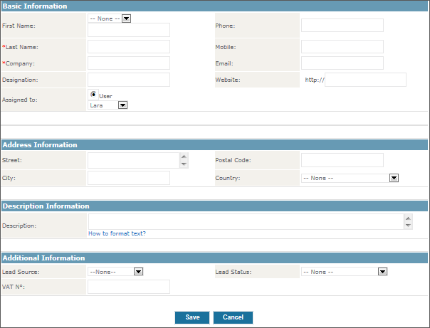
The data of Lead can be entered in shown form. If there is more users entering the data, our advise is to agree and define entry standards. In this way all the entered data are uniform. Redundant fields that you do not need can be left empty or just give us a call and we will remove them.
There is no need for most of the fields to be explained in details, for example:
- Surname
Surname is mandatory datum on shown form. If this field is not filled up, the entry can not be saved.
- Enterprise:
Enterprise is mandatory datum on shown form. If this field is not filled up, the entry can not be saved.
- Source of Lead
Here you can choose the source of acquiring the Lead. The source can be fair, conference and meeting, web page, etc.
- Rezultat kampanje:
In this field can be entered rezultat kampanje, s katero ste interesente pridobivali. From pull down menu can be choosen , da se je interesent javil sam, da ga morate poklicati oz. obiskati vi, da ga v tem trenutku vaša storitev ne zanima ipd.
- Ocena podjetja:
Tukaj lahko zapišete lastno oceno interesenta oz. podjetja. Lahko izberete, če je za vas interesent primeren ali ne oz. je že vaš kupec.
- Zadolžen:
V polju zadolžen lahko iz seznama uporabnikov izberite skrbnika interesenta. Sistem privzeto označi za skrbnika tistega, ki zapis vnese.
Po vnosu podatkov kliknite Shrani.

Import and export of Leads
At the beginning of/before you start using Produs IO there is a tool to help enter Leads vam pri vnosu interesentov pomaga tudi orodje za Uvoz podatkov. With import is easier to transfer/transmit more existant data from your previous lists and tools into Produs IO.
A list of Leads can also be import on one's own computer.
Read more about import and export in chapter Import and export data.

Pretvorba interesenta
Ko mislite, da se bo iz interesenta razvila posel, ga je potrebno pretvoriti.
Click on name of lead to open detailed view/view of details, as it is shown on the picture below.
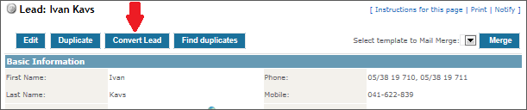
Click on (button) Pretvori|interesenta, that is marked with red arrow on the picture above. A new page is opened, as it is shown on the next picture:
S pretvorbo interesenta se samodejno zgodijo sledeče stvari:
- a new Account is created,
- a new Contact is linked with Account and
- a new Potential is created, that is linked with a new created Account and Contact.
- Lead is deleted.
Enter the data of a new potential in a form. If there is more users entering data, our advise is to agree and define entry standards. In this way all the entered data are uniform. Redundant fields that you do not need can be left empty or just give us a call and we will remove them.
There is no need for most of the fields to be explained in details, for example:
- Zadolžen:
Tukaj izberete zadolženega za podatke, ki bodo nastali po pretvorbi.
- Ne odpri novega posla po pretvorbi:
Če označite polje, bosta po pretvorbi nastala le nova stranka in kontakt. Nov posel ne bo nastal.
- Naziv posla:
Vnesite edinstveno ime posla, ki vas bo spominjalo točno na ta posel.
- Datum prodaje:
Izberite najprimernejši datum prodaje za ta posel. Kasneje ga lahko spremenite.
- Znesek prodaje:
Vnesite pričakovani znesek posla. Kasneje ga lahko spremenite.
- Verjetnost prodaje:
Vnesite verjetnost posla glede na vaš prodajni proces.
- Faza posla:
Vnesite prodajno fazo oz. status prodaje glede na vaš prodajni proces.
Click Save to perform transformation.
If the Account already exists, red notice will appear at the top of the form.
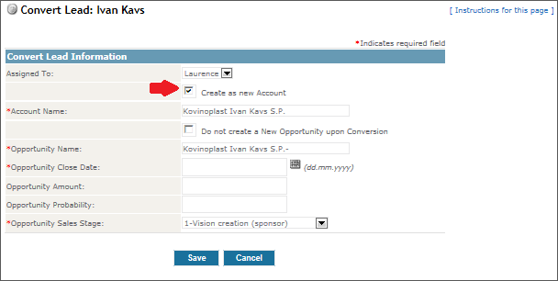
V tem primeru odznačimo polje Create as a new Account. Two buttons are shown (folder and eraser). By clicking on folder the S klikom na mapo lahko iz seznama strank izberete obstoječo stranko na katerega želite pripeti nov posel.
Po končani pretvorbi se vam bo odprlo novo okno, ki vam bo pokazalo detajlni pogled stranke, ki ste jo pravkar ustvarili. Na tem pogledu boste videli tudi, da sta nanjo navezana novo ustvarjena kontakt in posel.

