Related Records
The daily use of Produs Information Tool leads to increasing amount of entered records. This is why the tool contains mechanisms, which helps us easily find the record we need.
With the proper use of the tool, records cannot be lost in the mass data. It is important that each record is attached to an already existing record. Exception is a totally new record, for example a new lead.
All we need to know is the name of the account and through it we can access to the records linked to it, which means that records are properly attached to the account or its opportunities. We can immediately access to all records about the meetings or calls with our clients, contracts, opportunities… One click enables us to see the entire history of activities with our client.
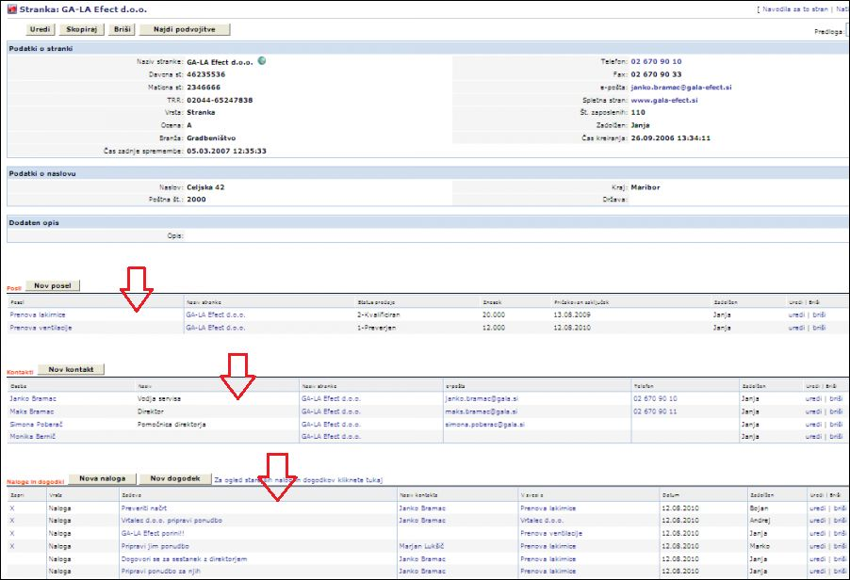?250

