Working with visiting card scanner
Atol company offers the visiting card scanning solution. Here are the instructions if you have chosen it.
The solution is mostly useful for people who acquire a lot of new Contacts in a fair or for those who do not enter the visiting cards simultaneously.

Scanning visiting cards
- We plug the visiting card scanner into the computer.
- We enter the visiting card with contents facing the floor.
- We press the scan button on the visiting card scanner.
- The visiting card scanner starts the program.
- We choose File/New so that an empty database opens.
- We scan the card again.
- After scan is complete we click the icon for a single visiting card view (as shown on the image below).
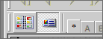
The scanned card appears on the left. The scanned data appears on the right (see image below).
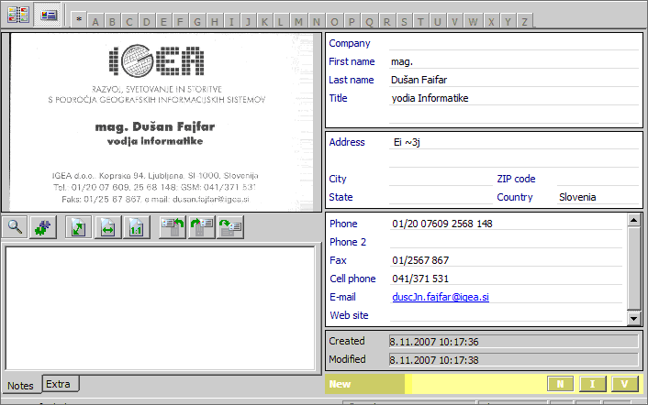
If the data is not completely transferred, we press the button with wheels.

„“
When the data on the right are properly entered, we verify them by clicking buttons I and V, situated underneath the data.

Then we continue with the next visiting card.
When we are done we click File/Close. The system asks if we wish to save data. We click „Yes“. We arbitrary rename the file and save it to desired folder.

Exporting scanned visiting cards
- We open the visiting card scanning program.
- We click File/Open and choose the file we wish to export.
- We click Edit/Select All.
- We click File/Export and Synchronize.
- A new window opens, as shown on the image below.
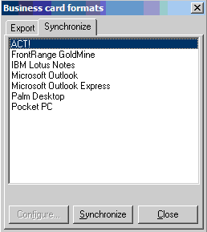
- We click the „Export“ tab«.
- We choose Text (*.CSV) from the list, as shown on the image below.
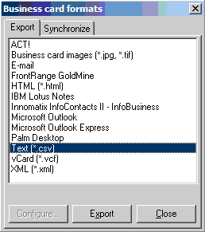
We click the »Export« button. We arbitrary rename the file and save it to desired folder.

Importing data into Produs IT
Read the Importing data chapter to learn more about importing data into the tool.

