Notifying
Notifications about individual records can be sent from the tool. Every record contains Instructions for this page and actions Print and Notify, as shown on the image below.
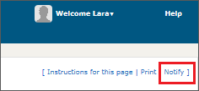
A click on Notify will open the form shown below.
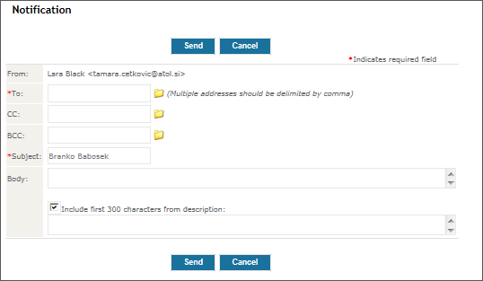
A click on the folder icon will reveal the list of the tool's users. You can choose them to receive notifications. If you wish to notify more users, just separate their e-mail addresses by commas.
The sent notification will also contain a link to the record.
The sent notification can include the first 300 words of record. If you would not want that, remove the tick above the field with the 300 words.

