Editing
Database is really useful only if it contains up-to-date data. That is why it is important to appoint someone who will manage and edit data of every Account and every Contact.
The data can be edited in two ways with the same results. The difference is only in accessing the edit.
- The first way is to choose a record and open detailed data of that record. A Edit button will appear on top of page (see the picture below).
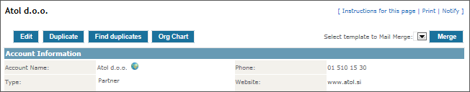
After you are done with the editing, click Save and you will be brought back to the detailed data of the record.
- The second way, also being faster, is to click the Edit button, located at the right edge of the list (see the picture below), directly from the overview.
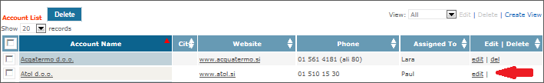
After clicking Save you will be brought back to the detailed data of the record.

