Creating views
Clicking any of the tabs will show a list of records. With frequent use the database will be filled with numerous notes and the offered lists will become saturated and difficult to examine.
That is one of the reasons for creating new views according to our needs. Usually user can create his own views as it suits him best. He can prepare them only for himself or share them with other users.
Produs IT enables different possibilities for creating views based on your own criteria.

Creating your own view
We will explain how to create your own view using an example list of customers. It is a general way and it applies to all the other modules.
While creating your own view you can set the following:
- content of the columns (which data should be shown),
- time interval in which the data was created or altered,
- different logical AND/OR operations between data, saved in the tool.
If you wish to create a new view, click New as shown on the image.
Copy
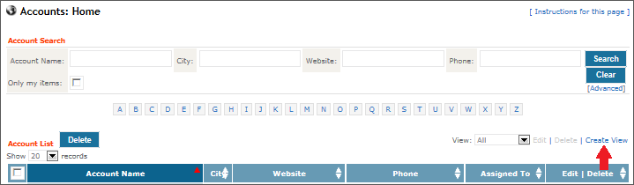
A new window will open (shown on the image below), where you can create your view.
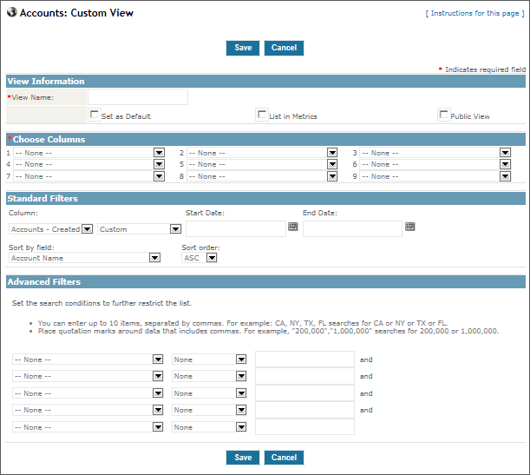
We recommend the following approach:
- Enter a short and unique name of the view into the View Name field.
- Choose number of columns in the Choose columns field. Bear in mind that the more columns you choose, the wider the view will be.
- You can set the time interval of the shown records in the Standard Filters area.
- The logical AND/OR operations for more precise data filtering can be set in the Advanced Filters area.
The new view can be set to default by marking the Set as default view, which is right below the Name of the view field. It will open up the moment you click the tab to enter the module.
You can include the view into the Key indicator by selecting the Range into statistics field. See the About entry page chapter for more information on the functionality of the key indicators.
As we already mentioned, you can create an view just for yourself or share it with other users. If you wish for others to see and use the view, select Seen by others.
When you are done, click the Save button.

