Changing Your Password
After logging into the system your password can be changed at any time. Just click Welcome tab in the upper right corner of the page.
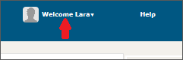
Clik the My Account button
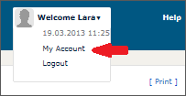
A new window opens. Click the Change Password button.
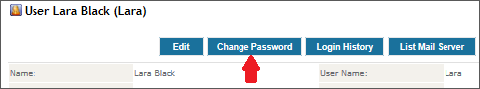
A new window opens. Enter the new password and confirm it.
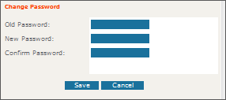
Click Save.

Changing other users' passwords
Passwords can also be changed by the system's administrator.
You have to be logged in in order to change passwords.
If you wish to change users' passwords, click Settings in the upper middle part of Produs IT.
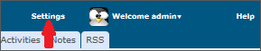
A page with settings will open. Click the first one on the list: Users.
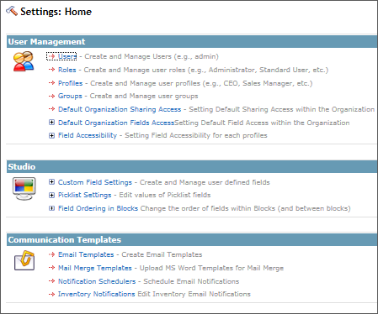
A list of users will open. Click the name of the user whose password you wish to change.
When detailed users information open, click Change password at the top of the page.
A new window will open. Enter a new password.
Save your entry by clicking Save.

